Crossroads International Church Dr. Rick Griffith
Title
16 March 2014 Series on Revelation Message 15 of 20
NLT 40 Minutes
Satan’s Henchmen
Revelation 13–14

Topic: Faithfulness
Subject: How should we live now when we know Satan will rule the whole world during the Tribulation?
Complement: Show your trust in Christ’s victory over Satan by being faithful now.
Purpose: The listeners will trust in Christ’s victory over Satan by being faithful now.
Meditation: Christ as Victor
Reading: Rev. 14:1-3
Song: Jesus, We Celebrate Your Victory - Billy Funk

Introduction

Interest: Perilous times often lead to dictators. [Quotes from here.]

France: In May 1789, France was bankrupt. “The bankruptcy of the French government led to the collapse of the monarchy, the French revolution, the Napoleonic wars, and the Dictatorship of Napoleon.”
Napoleon

Italy: “Mussolini came to power in a time of economic chaos in Italy. The first world war and its aftermath and the depression that began in 1929 brought many nations to the verge of bankruptcy. The tensions in domestic affairs in various nations led to a marked turn toward dictatorial forms of government, and to widespread repudiation of financial and moral obligations in the effort to solve domestic problems.”
Mussolini

Germany had the same pattern. After WWI, a single US dollar bought 10,000 Reichsmarks and the German government went bankrupt in 1931. With 6 million Germans unemployed, times were perfect for a dictator to take over—and the rest in history with Hitler’s rise to power.
Hitler

Need: Are things different today? Do you think the world is leading to more democracies or more dictators?
D or D?

The USA is now the world power, but it is still in the most serious financial crisis since the Great Depression.
US Flag

The housing bubble burst in 2007, but, a little known fact is, mortgage defaults have increased up to 2013! This is why we don’t own a home!
Housing
(3 slides)
Private Debt

Private debt is HUGE! Still, the rapidly expanding national debt of the U.S…increased from 10 trillion dollars in 2009 to $17.5 million in 2014, having increased under the current administration by over 7 trillion dollars. At the end of 2012 “the debt… reached over 100% of GDP for the first time since the aftermath of World War II” (source).
National Debt

This means every American citizen's share of this debt is $55,108.98.
$55k

On 20 January 2009 Reuters columnist John Kemp noted that, “The United States and the United Kingdom stand on the brink of the largest debt crisis in history” (source). That was five years ago but we’re 7 trillion worse now!
Arrow down

Most Americans think they live in a democracy—but they don’t!
Democracy?

One history teacher says, “The word ‘democracy’ comes from two Greek words: demos meaning ‘the people’ and kratia meaning ‘to rule,’ therefore democracy means ‘the people rule.’ Majority rule may sound like a good idea, but, essentially, it translates to mean ‘mob rule’” (source).
Demo meaning

Thomas Jefferson said, “A democracy is nothing more than mob rule, where fifty-one percent of the people may take away the rights of the other forty-nine.”
Jefferson

However, the US pledge reads, “I pledge allegiance to the flag of the United States of America, and to the republic for which it stands…” A republic means a government based on a guiding document. That was the original USA—based on the US Constitution.
We the People
Republic

Nevertheless, now the mission of the USA is to spread democracies around the world, which means systems based on majority rule. The problem is that the majority is often wrong—and it can elect a dictator! In other words, the rise of democracies is a step toward one world government we will see in Revelation 13.
Elect dictators
Elect dictators

Background: Today is message 15 in our 20-sermon series on Revelation. John wrote book of Revelation when the dictator Domitian ruled the Roman Empire.
Chronology Timeline

The literary context is dictatorship.

We have just seen Revelation 12’s overview of Satan’s agenda through the ages to fight God and persecute Israel.
Rev 12

Chapters 13–14 end “The Great Parenthesis” of chapters 10–14. Here the lens zooms in on the Tribulation Period with how Satan empowers his “henchmen” to wreck havoc on the earth prior to Christ’s Return.
Parenthesis

The historical context is also dictatorship.

The first century had its share of good and bad leaders, but Revelation was written during the horrible reign of the Emperor Domitian.
Emperors

Domitian (AD 81-96), Titus’ brother, initially had many accomplishments. But his demand to be called “Lord and God” and severe paranoia led to a reign of terror—rivals were executed, philosophers expelled from Rome, and Christians suffered martyrdom. John wrote the Book of Revelation near the end of his reign while in exile on the Island of Patmos. Finally Domitian was assassinated. Thus ended the NT era of Roman emperors.
Domitian

Some believe Domitian to be the “beast” of Revelation 13. However, he did not implement a system of buying and selling with the mark, as well as other differences.

Subject: How should we live now when we know Satan will rule the whole world during the Tribulation?
Subject

Preview: Revelation 13 will focus on Satan’s leadership and chapter 14 will zoom in on Christ’s response.
13 v 14
Hitler
(How will Satan control the Tribulation world to come? Just as Hitler had his henchmen so…)

I. Satan will rule the world through his two key henchmen (Rev. 13).
MP
[The devil in the form of a dragon will control all nations through two “beasts.”]

The Antichrist (“beast out of the sea”) will seize world power through Satan and will persecute Christians (13:1-10).
1

The sea beast will control the world by a death-and-resurrection ploy to lure unbelievers to worship him and Satan (13:1-4).

Why is he called a “beast”? Wiersbe notes, "The symbolic description of 'the beast' enables us to learn something about his origin and character. God does not see him as a man, made in the divine image, but as a wild animal, under the control of Satan. He is a man (Rev. 13:18); but he is energized from hell, for he comes out of the pit (Rev. 11:7; 17:8). Just as Jesus Christ is God in the flesh, so 'the beast' will be Satan in a human body (see John 13:2, 27).”
Why beast?

Why rising from the sea? Walvoord writes, “The fact that the beast comes out from the sea indicates that he is a Gentile, for the sea of humanity is involved as his source (cf. Rev. 17:15).”
Why sea?

What does “the sea” symbolize? The answer is in 17:15, “The waters where the prostitute is ruling represent masses of people of every nation and language" (NLT).
What sea symbol?

He is a kingdom composed of Daniel 7’s various kingdoms (13:1-2).
2 +
(6 slides)

His strategy will be to fool people by miracles so that he will be adored and worshipped by unbelievers (13:3-4).
Worship
3-4
wound

The sea beast will blaspheme God and persecute believers (13:5-10).
5-7

He will blaspheme God and be worshipped (13:5-8).
8

He will persecute believers for 42 months and require of them faithful and patient endurance (13:9-10).
9-10

The False Prophet (“beast out of the earth”) will glorify the Antichrist and persecute Christians who lack Antichrist’s mark (13:11-18).
Land beast

The land beast’s miracles will lure the world to worship the sea beast as if in a satanic trinity (13:11-14). Wiersbe calls him Antichrist’s “propaganda minister”!
Satanic Trinity

Those refusing to worship the Antichrist or take his mark will be killed and prevented from buying or selling (13:15-17).
16-17
(2 slides)

The number of Antichrist’s name and mark is 666 as it is triple man’s number of 6 (13:18). All attempts to identify him have failed!
MPI
Who is he?
(17 slides)

(So Satan and his henchmen will rule the world! Will anyone survive the Tribulation? Yes!)
Survive?

II. Christ will defeat Satan through 144,000 Jews and six more angels (Rev. 14).
MPII
[Over 144,000 will remain faithful to the end, so heed the six angels!]

The 144,000 Jews who live through the Tribulation by following Christ the Lamb anticipates all those victorious at the Second Coming (14:1-5).
Close up
144,000

Three angels command fear of God by rejecting the mark of Antichrist to encourage believers to wait patiently for Christ's return (14:6-13).
6-7
(6 slides)

The first angel commands worship due to God being creator (14:6-7).

The second angel laments that Babylon falls at this point (14:8).
Angel 2
14:8

The third angel warns that taking the beast’s mark leads to hell (14:9-13).
Rest
14:13
Angel 3
14:9-11

Three more angels assist in the final judgment of unbelievers by Christ, previewed through grapes trodden in a winepress (14:14-20).
3 Angels
(14-20)

Jesus is ready to judge the earth at this point (14:14).
14

Who is the “son of man” here (14:14)? This is Jesus, as he has the same title in 1:15 and over 25 times in Matthew’s gospel (Matt. 8:20; 9:6; etc.).

Since Babylon has already been judged at this point (v. 8), these verses depict events associated with the bowl judgments of chapters 15–16.

This passage is telling us that Christ’s coming is right at the door at the end of the Tribulation! As such, he has the right to judge the earth.

Christ is commanded by an angel to judge, but is the harvesting the earth bringing people to Christ or judgment (14:15-16)? The latter is supported since “the ripeness is in the sense of withered or overripe (e˙xhra¿nqh)” (BKC).
17-18
15-16

Two more angels now also judge the earth. One even can destroy with fire!

But the other judges the earth also under the figure of a sickle harvesting grapes.
Grapes

Grapes in 14:19-20 are a good picture of blood—and this blood splashes up a meter from the ground for 290 kilometers!
19-20

(How should we live now when we know Satan will rule the whole world during the Tribulation [subject repeated]?)
Subj

Conclusion

Show your trust in Christ’s victory over Satan by being faithful now (MI).
• MI

Knowing the Lamb’s victory over the awesome power of the dragon and his beasts should motivate us to faithful endurance [MI restated].

These two chapters each have one key exhortation—to remain faithful!

Since Satan will lead the world by empowering his agents,
show faithful endurance (13:10).
• Endure
MPI

Since Christ will give the 144,000 Jews victory over Antichrist,
show faithful endurance (14:12).
• Endure
MPII

How can you show faithful endurance now?
How?

Bloom where you're planted.
• Bloom

Impact your marketplace.
• Mkplc

Invest your money for eternity.
• Money

Use your talents for Christ.
• Talents

Resist total allegiance to the State.
• State

Stop making excuses.
Excuses

Stay faithful for decades.
Decades

Prayer
Black

Preliminary Questions

Verses Questions

Context: What did the author record just prior to this passage?

We have just seen Revelation 12’s overview of Satan’s agenda through the ages to fight God and persecute Israel.

Chapters 13–14 end “The Great Parenthesis” of chapters 10–14

Purpose: Why is this passage in the Bible?

Now the lens zooms in on the Tribulation Period with how Satan empowers his “henchmen” to wreck havoc on the earth prior to Christ’s Return.

Background: What historical context helps us understand this passage?

The book of Revelation was written during the horrible reign of the Emperor Domitian.

Domitian (AD 81-96), Titus’ brother, initially had many accomplishments. But his demand to be called “Lord and God” and severe paranoia led to a reign of terror—rivals were executed, philosophers expelled from Rome, and Christians suffered martyrdom. John wrote the Book of Revelation near the end of his reign while in exile on the Island of Patmos. Finally Domitian was assassinated. Thus ended the NT era of Roman emperors.

Some believe Domitian to be the “beast” of Revelation 13. However, he did not implement a system of buying and selling with the mark, as well as other differences.

Questions

What is the significance of the Antichrist “rising up out of the sea” (13:1)? Does this mean he will be from an island or something?

What entities comprise the ten horns and seven heads (13:1)? These likely indicate two types of alliances of nations.

How can ten horns fit on seven heads (13:1)? We shouldn’t worry about biblical imagery, as more than one horn is on many animals. Some obviously have more than one horn, as does a bull.

What do the three types of animals that comprise the beast mean (13:2)? Daniel associates these animals with Babylon (lion), Greece (leopard) and Persia (bear), so likely the beast will be like these nations.

Will Satan himself possess the Antichrist (13:2)? Sounds like it!

When does the 42 months take place—at the beginning or end of the Tribulation (13:5)? This must be the end as it notes great persecution typical of the end.

Are “God’s holy people” whom the beast conquers Israel (13:7)? This seems to be a more general description of all believers then.

Is prison and the sword for those whom it is destined fatalism (13:10)? No, the end of the verse says that they must endure persecution and remain faithful!

Who is the beast from the earth (13:11)?

What is significant about him being from the earth (13:11a)?

Why two horns on this beast (13:11b)?

Why will the False Prophet require all to worship the Antichrist (13:12)?

Can miracles come from satanic power (13:14)?

What is the aim of worshipping a statue of the first beast instead of worshipping the beast himself (13:15)?

Why would a mark be on people’s right hand or forehead (16)?

Why would the beast’s number be 666 (13:18)?

Where is the Mount Zion—earth or heaven (14:1)?

What’s the role of 144,000 singing here (14:1-5)?

They were already noted in 7:4-8 as Jews who witness on earth during the early part of the Tribulation. Here we see them having all lived through the Tribulation to this point.

“Some people believe that the 144,000 will be evangelists in the Great Tribulation. But there is no indication that the 144,000 were preachers or prophets; their testimony was largely from their moral purity and the fact that they were not martyred like many others” (Walvoord, BKC).

Who is the “son of man” on the cloud (14:14)? This is Jesus, as he has the same title in 1:15 and over 25 times in Matthew’s gospel (Matt. 8:20; 9:6; 11:19; 12:8, 32; 13:41; etc.).

Is the harvesting the earth bringing people to Christ or judgment (14:15-16)? The latter is supported since “the ripeness is in the sense of withered or overripe (e˙xhra¿nqh)” (BKC).

What’s the point of Revelation 14?

“Taken as a whole, Revelation 14 on the one hand refers to the preservation of the 144,000 through the Great Tribulation. And on the other hand it graphically declares some of the terrible judgments that will be inflicted on the world which rejects Christ and follows Satan’s substitute for the Lord.”

“William Kelly regards this chapter as an outline of major events at the end of the Age: (1) the appearance of the godly remnant of Israel; (2) a testimony to Gentiles; (3) the fall of Babylon; (4) the doom of the worshipers of the beast; (5) the blessedness of saints who are martyred; (6) the harvest; (7) the wrath of God on the world (Lectures on the Book of Revelation, p. 330)” (Walvoord, BKC).

Tentative Subject/Complement Statements

Text

Possible Illustrations

“The lesson in this is that if the U.S. economy collapses, or there is a collapse of the world's economy, new political realities will follow. Such an economic collapse is considered by many observers to be very likely in the not too distant future. And such an event could well lead to the prophesied emergence of a united Europe under a dictatorship, what the Bible calls the ‘Beast’ (Revelation 13:1-8; 17:12-14).

Even if Revelation 13 doesn’t relate at all to a USA financial collapse, it is sure to happen. So what should we do about it now?

Possible Applications

Text
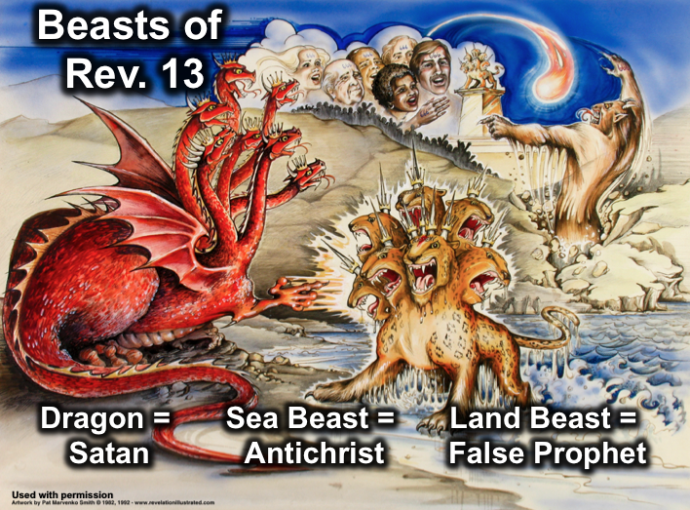

(Ch. 13) Satan's agents (the Antichrist and False Prophet) are identified to enable readers of the Tribulation Period to resist them.

(13:1-10) Antichrist, represented by the beast out of the sea, gains a worldwide following by unbelievers through satanic power and persecutes Christians.

(13:11-18) The False Prophet, represented by the beast out of the earth, glorifies the Antichrist and persecutes Christians who lack the mark of the Antichrist.

Who is the Beast?

(Rev. 14) The triumph of 144,000 Jews and Antichrist’s judgment (with his system) preview the judgments at the end of the Tribulation in chapters 15–17.

(14:1-5) The triumph of the 144,000 Jews who escape martyrdom in the Tribulation anticipates Christ's triumph at His Second Coming.

(14:6-13) Three angels shout warnings to fear God by rejecting the mark of Antichrist since his system is doomed to encourage believers still living to wait patiently and faithfully for Christ's return.

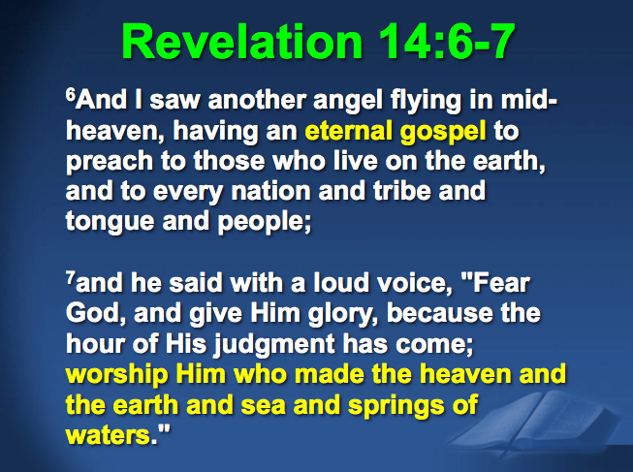

Satan is seeking to destroy belief today in Christ as creator through the lie of evolution…

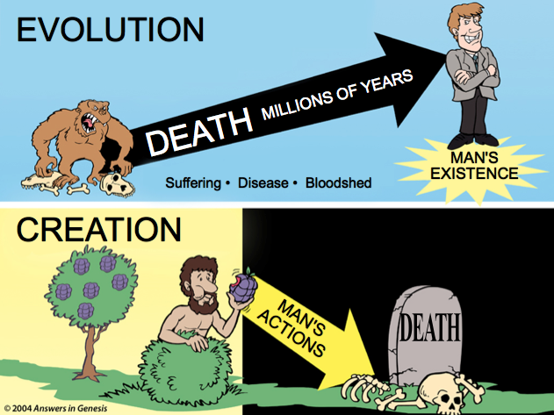

If one destroys the foundation in creation, then he also destroys the final creation where the first creation finds its consummation.

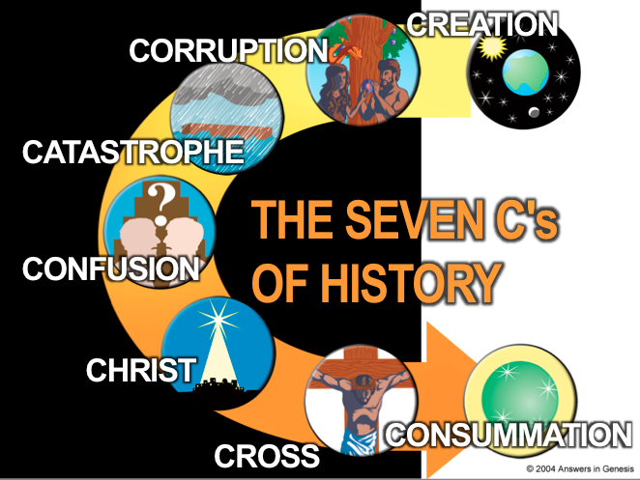

(14:14-20) The final judgment of unbelievers by Christ, with the assistance of three angels, is previewed through the figure of grapes trodden in a winepress.

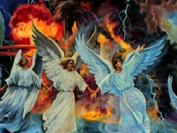
Satan’s Henchmen
Revelation 13–14

Exegetical Outline (Steps 2-3)

Exegetical Idea: The way believers should respond to the triumph of 144,000 Jews and the judgment of Antichrist is to show faithful endurance.

I. The way believers should respond to Satan leading the world by empowering his agents (the Antichrist and False Prophet) is to show faithful endurance (Ch. 13).

The Antichrist (“beast out of the sea”) will seize world power through Satan and will persecute Christians (13:1-10).

The sea beast will control the world by a death-and-resurrection ploy to lure unbelievers to worship him and Satan (13:1-4).

The sea beast will persecute believers for 42 months and require of them faithful and patient endurance (13:5-10).

The False Prophet (“beast out of the earth”) will glorify the Antichrist and persecute Christians who lack Antichrist’s mark (13:11-18).

The land beast’s miracles will convince the world to worship the sea beast (13:11-14).

Those refusing to worship the Antichrist or take his mark will be killed and prevented from buying or selling (13:15-17).

The number of Antichrist’s name and mark is 666 as it is triple man’s number of 6 (13:18).

II. The way believers should respond to the triumph of 144,000 Jews and Antichrist’s judgment (with his system) is to show faithful endurance (Rev. 14).

The triumph of the 144,000 Jews who will escape martyrdom in the Tribulation by following Christ the Lamb anticipates all victorious at the Second Coming (14:1-5).

Three angels command fear of God by rejecting the mark of Antichrist and his doomed system to encourage believers to wait patiently for Christ's return (14:6-13).

Three more angels assist in the final judgment of unbelievers by Christ, previewed through the figure of grapes trodden in a winepress (14:14-20).

Purpose or Desired Listener Response (Step 4)
The listeners will trust in Christ’s victory over Satan by being faithful now.

Homiletical Outline (Cyclical inductive form)

Introduction

Interest: Perilous times often lead to a dictator.

Need: Do you think the world is leading to more democracies or more dictators?

Background: John wrote book of Revelation when the dictator Domitian ruled the Roman Empire.

Subject: How should we live now when we know Satan will rule the whole world during the Tribulation?

Preview: Revelation 13 will focus on Satan’s leadership and chapter 14 will zoom in on Christ’s response.

(How will Satan control the Tribulation world to come?)

I. Satan will rule the world through his two key henchmen (Rev. 13).

The Antichrist (“beast out of the sea”) will seize world power through Satan and will persecute Christians (13:1-10).

The sea beast will control the world by a death-and-resurrection ploy to lure unbelievers to worship him and Satan (13:1-4).

The sea beast will blaspheme God and persecute believers (13:5-10).

The False Prophet (“beast out of the earth”) will glorify the Antichrist and persecute Christians who lack Antichrist’s mark (13:11-18).

The land beast’s miracles will lure the world to worship the sea beast as if in a satanic trinity (13:11-14).

Those refusing to worship the Antichrist or take his mark will be killed and prevented from buying or selling (13:15-17).

The number of Antichrist’s name and mark is 666 as it is triple man’s number of 6 (13:18).

(Will anyone survive the Tribulation? Yes!)

II. Christ will defeat Satan through 144,000 Jews and six more angels (Rev. 14).

The 144,000 Jews who live through the Tribulation by following Christ the Lamb anticipates all those victorious at the Second Coming (14:1-5).

Three angels command fear of God by rejecting the mark of Antichrist to encourage believers to wait patiently for Christ's return (14:6-13).

Three more angels assist in the final judgment of unbelievers by Christ, previewed through grapes trodden in a winepress (14:14-20).

(How should we live now when we know Satan will rule the whole world during the Tribulation [subject repeated]?)

Conclusion

Show your trust in Christ’s victory over Satan by being faithful now (MI).

Knowing the Lamb’s victory over the puny power of the coming beasts should motivate us to faithful endurance [MI restated].

Since Satan will lead the world by empowering his agents,
show faithful endurance (13:10).

Since Christ will give the 144,000 Jews victory over Antichrist,
show faithful endurance (14:12).

How can you show faithful endurance now?

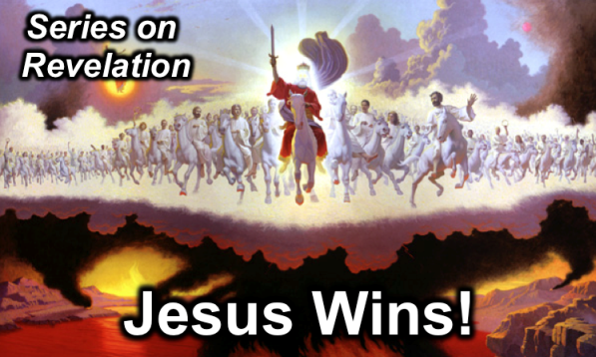
Rick Griffith
16 March 2014
Message 15 of 20

Satan’s Henchmen
Revelation 13–14

Introduction

Perilous times often lead to a dictator.

Do you think the world is leading to more democracies or more dictators? Why?

John wrote book of Revelation when the dictator Domitian ruled the Roman Empire.

How should we live ______________ when we know Satan will rule the whole world during the Tribulation?

(How will Satan control the Tribulation world to come?)

I. Satan will rule the world through his two key _____________________ (Rev. 13).

The Antichrist (“beast out of the sea”) will seize world power through Satan and will persecute Christians (13:1-10).

The sea beast will control the world by a death-and-resurrection ploy to lure unbelievers to worship him and Satan (13:1-4).

The sea beast will blaspheme God and persecute believers (13:5-10).

The False Prophet (“beast out of the earth”) will glorify the Antichrist and persecute Christians who lack Antichrist’s mark (13:11-18).

The land beast’s miracles will lure the world to worship the sea beast as if in a satanic trinity (13:11-14).

Those refusing to worship the Antichrist or take his mark will be killed and prevented from buying or selling (13:15-17).

The number of Antichrist’s name and mark is 666 as it is triple man’s number of 6 (13:18).

II. Christ will defeat Satan through 144,000 Jews and six more ______________ (Rev. 14).

The 144,000 Jews who live through the Tribulation by following Christ the Lamb anticipates all those victorious at the Second Coming (14:1-5).

Three angels command fear of God by rejecting the mark of Antichrist to encourage believers to wait patiently for Christ's return (14:6-13).

Three more angels assist in the final judgment of unbelievers by Christ, previewed through grapes trodden in a winepress (14:14-20).

(How should we live now when we know Satan will rule the whole world during the Tribulation?)

Conclusion

Show your trust in Christ’s victory over Satan by being __________ now (Main Idea).

Knowing the Lamb’s victory over the puny power of the coming beasts should motivate us to faithful endurance.

Since Satan will lead the world by empowering his agents,
show faithful endurance (13:10).

Since Christ will give the 144,000 Jews victory over Antichrist,
show faithful endurance (14:12).

How can you show faithful endurance now?

Thought Questions:

- Read Revelation 13–14. Contrast these two:

Satan’s Plan (Rev. 13) | God’s Plan (Rev. 14)

- How would you put 13:10 and 14:12 in your own words?

- If there is one thing that keeps you from enduring for Christ, what is it? Family? Your addiction to _______________? Fear of _________________?

